Antipodes 2023 Sydney to Auckland Yacht Race
7th – 12th October 2023
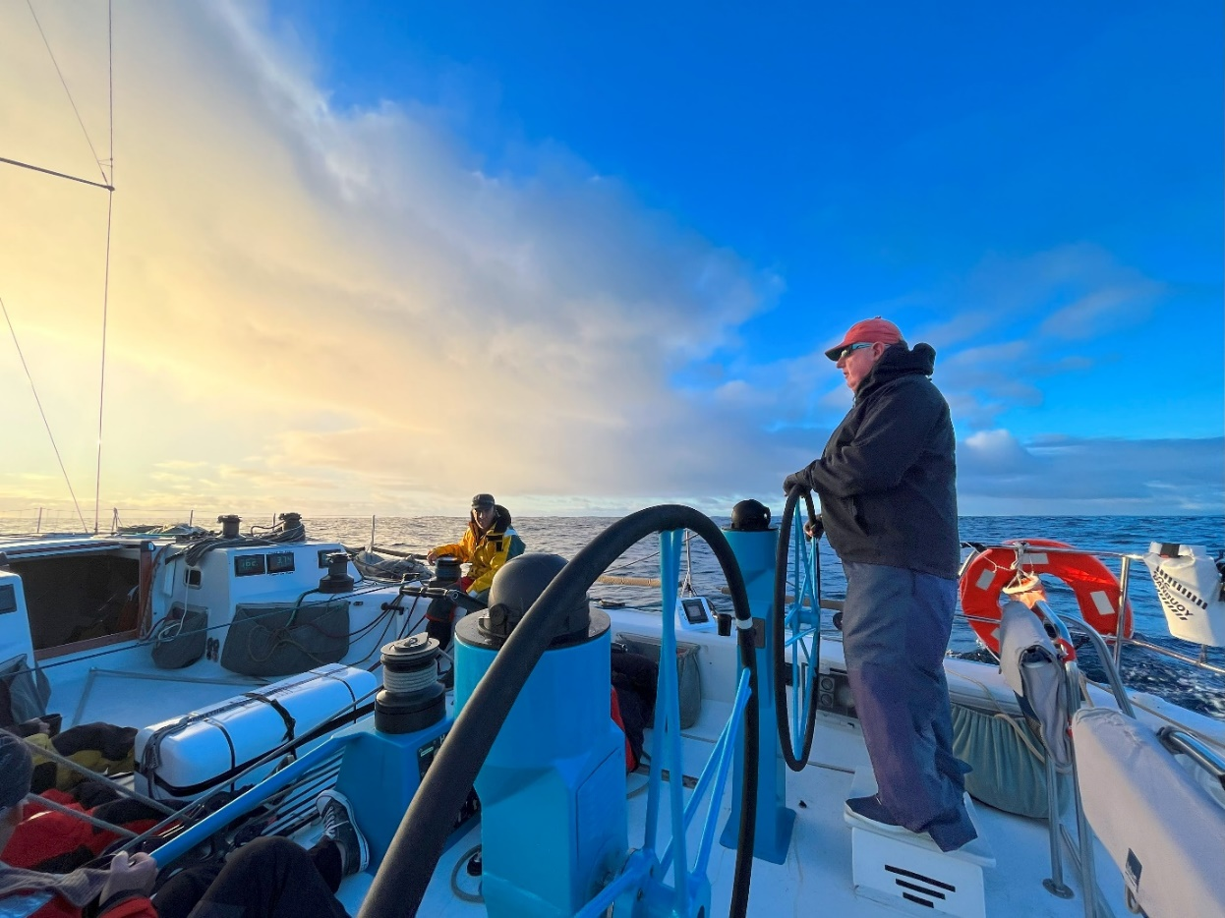
Log
Saturday 7th October 2023
1300 Start slightly North of Sow & Pigs. Red channel marker used for timed runs. Not the best start but safe. FM, J2 & GS.
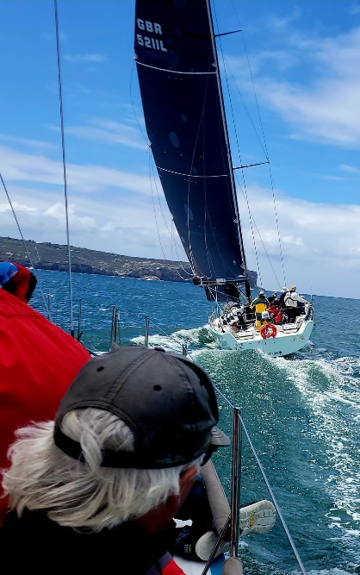
1305 Hallam has massive 4 x o’boy on stbd runner.
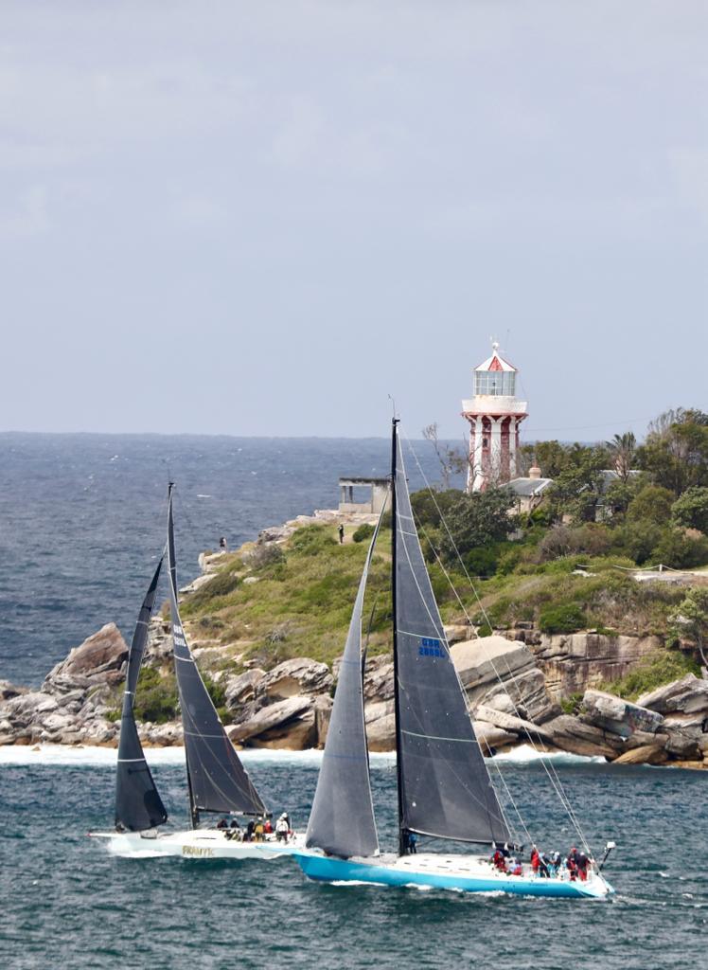
1310 East of North Head beacon. Stop boat, fix runner o’boy.
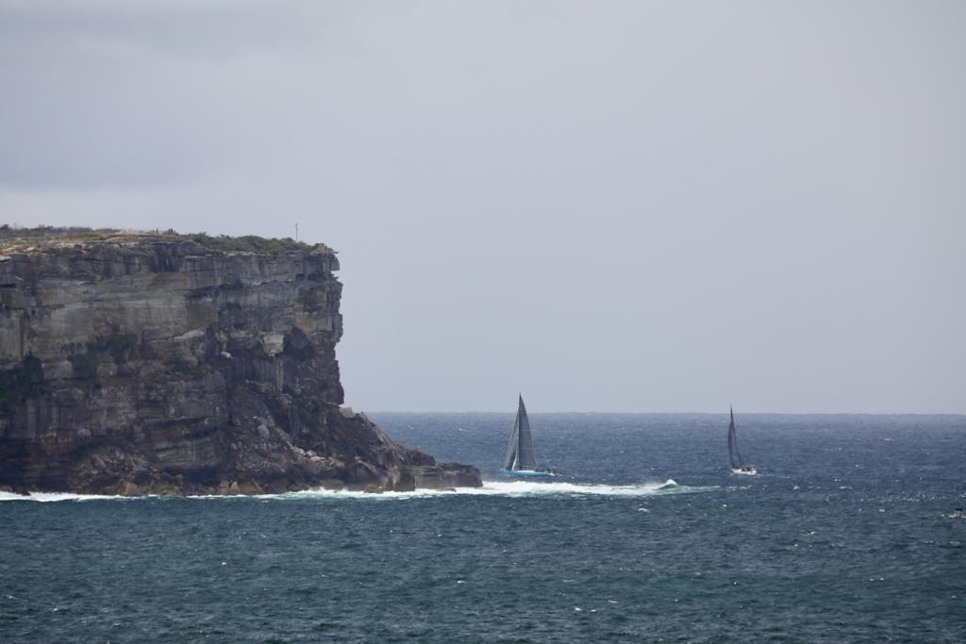
1312 Hoist A4 & SS, GS down.
1500 Barrenjoey Mark. J2 up, A4 down (Ralph had one after halyard was caught at mast exit), poor drop. Starting to head east.
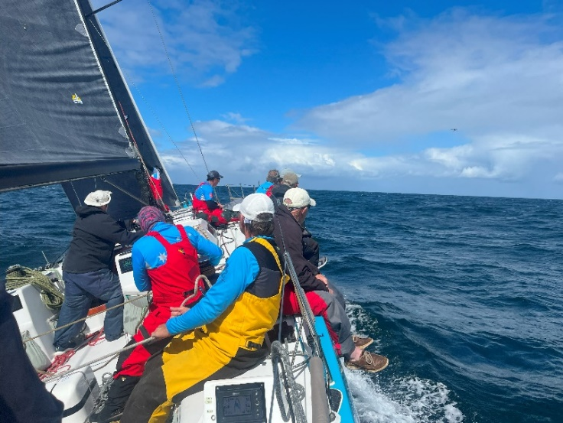
Sunday 8th October 2023
1830 Inboard runner block shackles rock down in chainplate and get caught. Runner block safeties around chainplate and not the shackle.
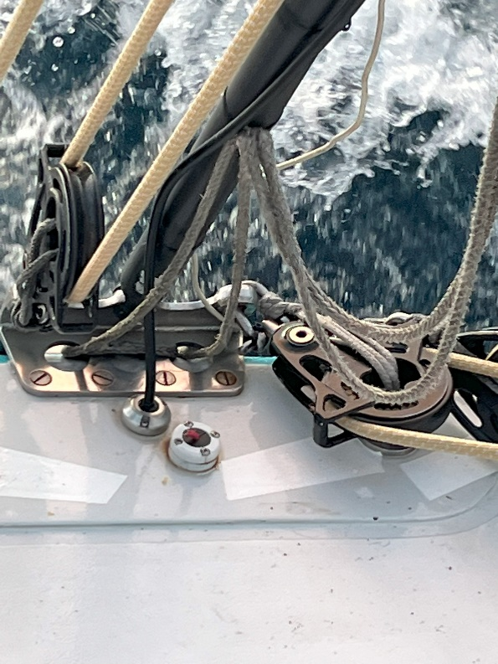
2350 Code 0 deployed, J2 down, GS up.
Monday 9th October 2023
0920 A3 & GS. Code 0 down. Tear in A3 notices at hoist. (repaired by Marky after halyard snap tea-bagging it).
1330 Red MH spin halyard snaps 500mm from clip. Tea-bags A3. A4 hoisted (about time for the peel anyway). Start looking for noted repair.
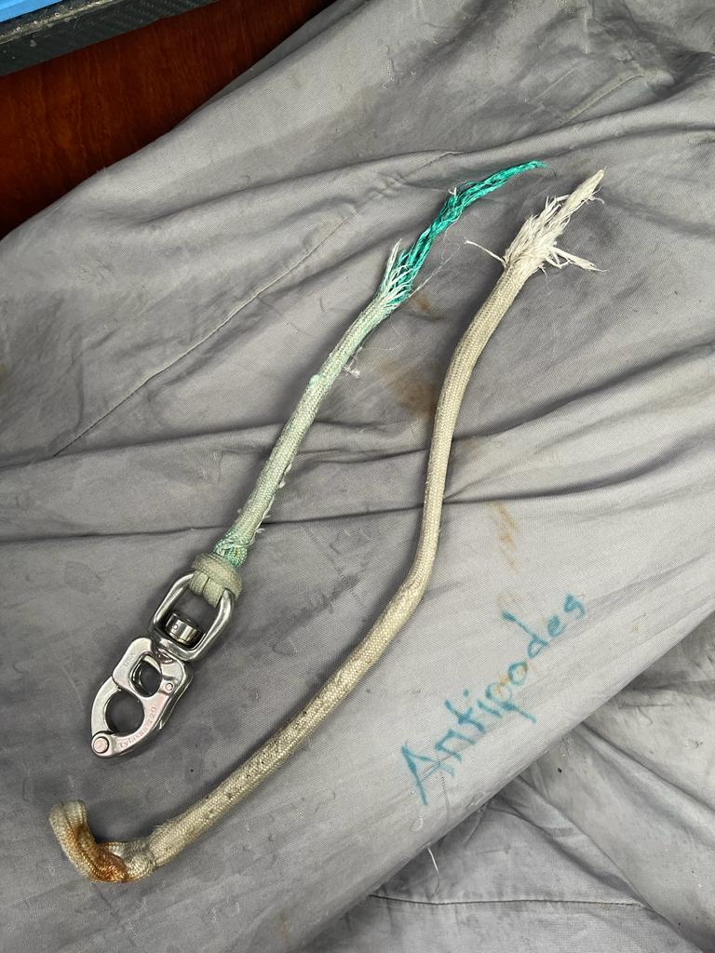
1352 Marky repairs A3 hole noticed when hoisted.
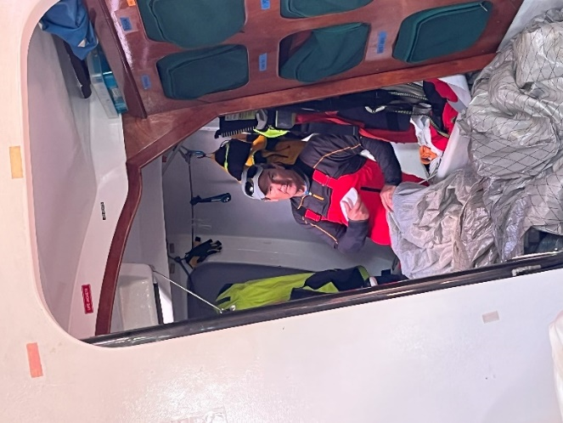
1800 Peel A4 to A2 + SS.
2200 A2 head ring parts and then A2 tea-bagged. Two tea-bags in one day. WOW. A6 hoisted. SS Down, GS up. Under wicked.
Tuesday 10th October 2023
0100 Wind softens, sailing hotter angle. Expedition freezing when Tooltip shut down. Stop using Tooltip when left on.
0700 J2 hoisted, A6 down, mainsail down. Send Damo aloft on main halyard to retrieve MH halyard.
0735 Full Main.
0740 A2 hoisted into 4kts wind. SS hoisted on standby.
1130 Gybe onto port.
1140 Spot Frantic stbd aft quarter.
1220 Disagreement with Camel driving about SS which was furled. Chat with Geoff about the situation.
1245 SS deployed. Talk with Watch 2 about SS trimming.
1320 Gybe onto stbd.
1400 Talk through SS trimming with Watch 1.
2000 A2 tack ring breaks. Take down line tied to coachroof. Pull in under boom. A4 hoisted.
2020 Camel broaches with A4 & SS. SS furled. 16-18kts TWS on H5000 feels more like 20+kts. A4 better than A2.
2110 Adjust TWS updraft calculation to read higher by 5%.
2315 Green halyard snapped 300mm from clip and A4 tea-bagged. Third tea-bag for the race. SS deployed. A6 hoisted. SS down & GS hoisted. Potential tear in A4.
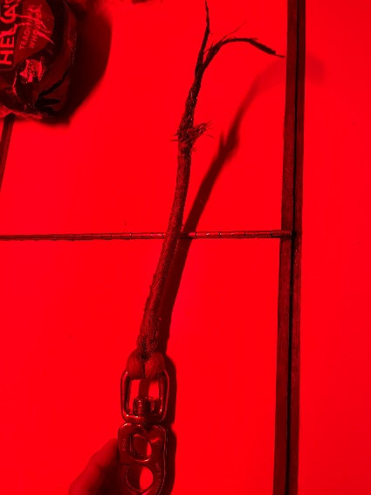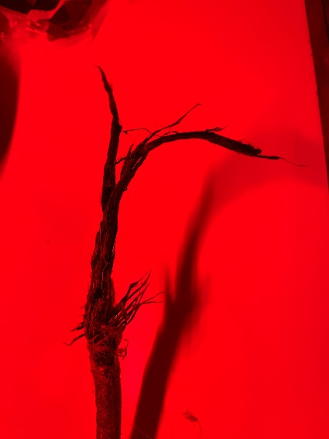

Wednesday 11th October 2023
0745 Disappointing sked with Frantic 2NM ahead.
1730 J2 hoisted, outboard sheet, A6 down.
2130 Code 0 hoisted. J2 on deck, plugged in. Halfway from Cape Reigna to North Cape.
2300 Abeam North Cape. J2 hoisted, Code 0 on deck plugged in.
Thursday 12th October 2023
0310 Code 0 hoisted & GS, J2 on deck plugged in.
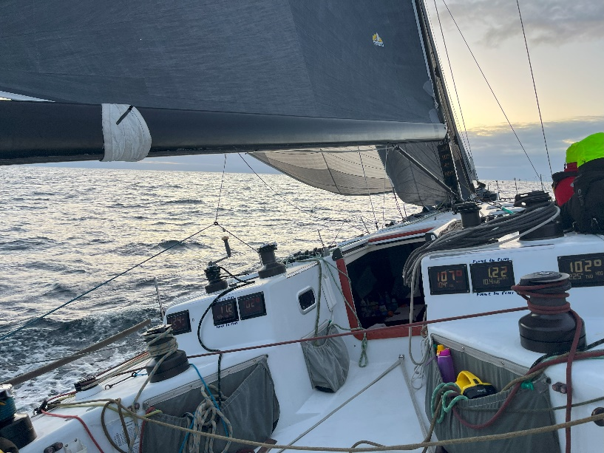
0630 Cape Brett
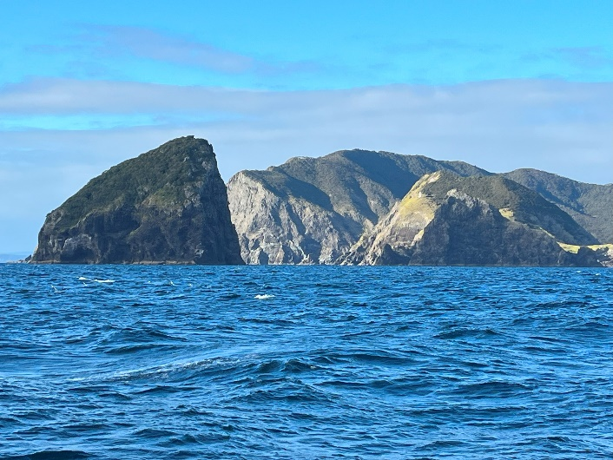
0645 J2 hoisted, Code 0 on deck and packed.
1215 – 1225 J2 – J4 bare headed peel.
1230 Reef 1. All went well. M1R & J4.
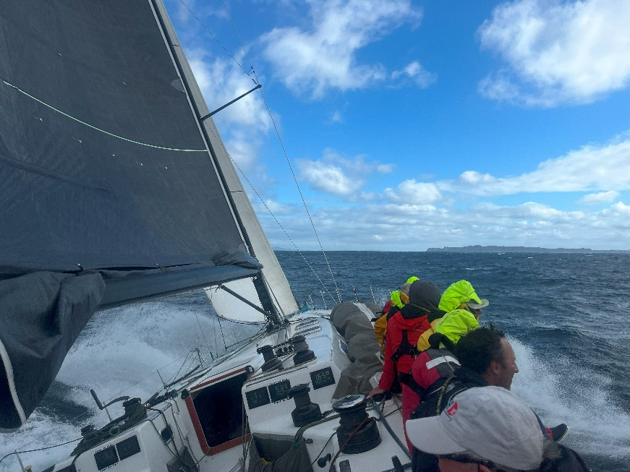
1637 Finish.
